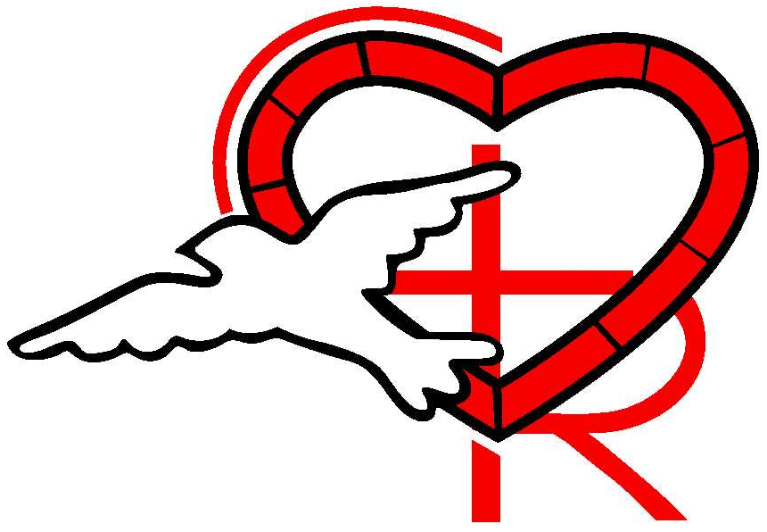

2024

Annual Report

Christ Our Redeemer
Lutheran Church

304 Druid Hills Road
Temple Terrace, FL 33617
(Phone) 813-988-4025

www.corlutheran.org


Our mission as Christ Our Redeemer Lutheran Church is to be people of God gathered around word and sacrament. Therefore, we proclaim the love of God in Christ Jesus through the power of the Holy Spirit. We do this through worshipping, learning, supporting, witnessing, and serving.

Proclaim the Love of Christ

Our Staff
2024
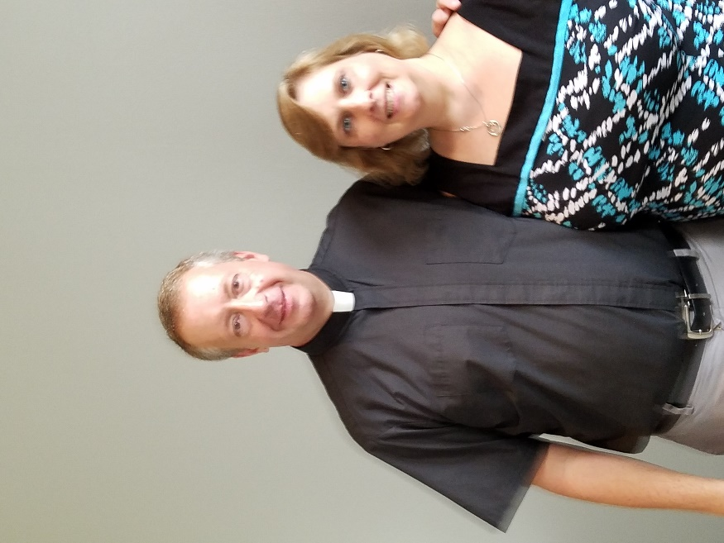

Eric Friedrichs
Pastor

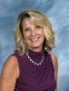
Keith Miller
Bookkeeper
Vickie Sufka
Parish Administrator
Deacon Tara Friedrichs
Director of Faith Formation
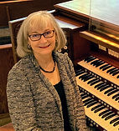
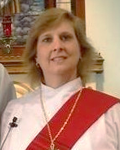

Chris Robinson
Music Director
Elizabeth Chester
Organist

Church Council Officers and Ministry Team Chairpersons
Church Council Officers and Ministry Team Chairpersons
2024
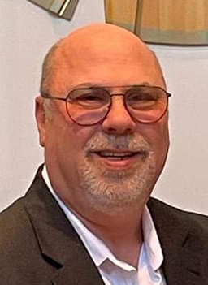
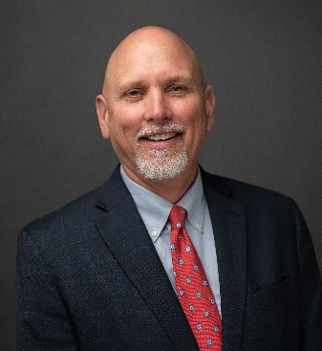

President-Elect
Bob Singagliese
President
Todd Anderson

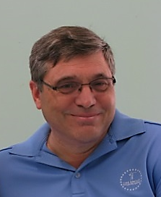
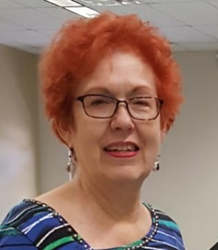
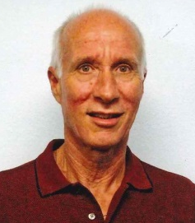

Treasurer
John Bauder
Secretary
Sharon Occhipinti
Financial Secretary
Kevin Sigl
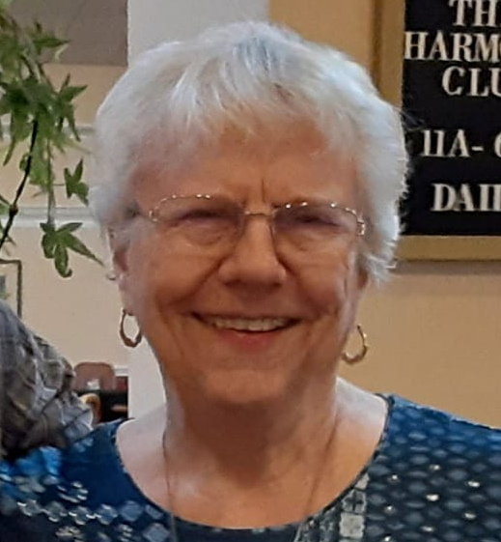
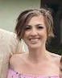
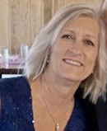
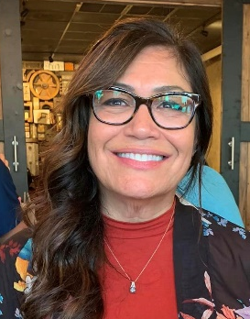

Member Care
Diana Lyles
Education
Tilly Anderson
Fellowship
Candice & Sharon Fraga

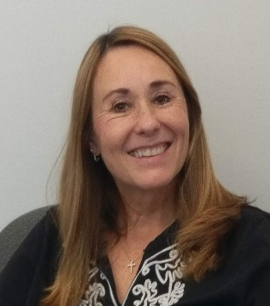
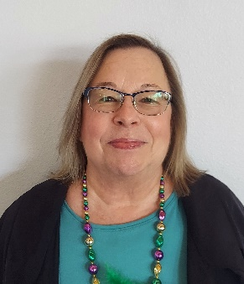
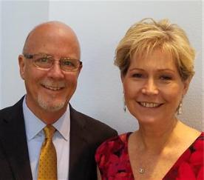
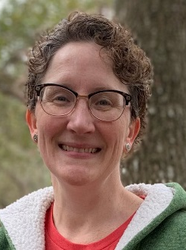

Outreach
Christina Mayorga
Social Ministries
Jan Van Bibber
Worship
Jeanne Singagliese
Property
Ken Oleson

President’s Report

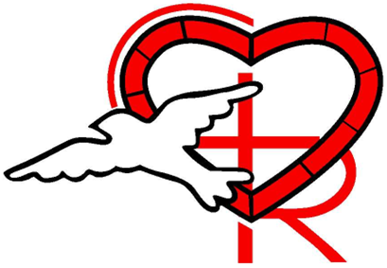
Dear Church Family,
What a fast year 2024 was! I want to extend a heartfelt THANK YOU to our staff, the COR Council, and all our dedicated members kicking in to accomplish all we have done. All of your dedication, compassion, and hard work have been instrumental in nurturing our spiritual growth and supporting our church’s mission. A few of the highlights this year I want to point out are:
- Starting The Table (Campus Ministry): A long discussed and much needed connection to college aged adults in the area.
- Church connections and services at Discovery Village and Concordia: A fantastic new outreach that strengthens our ties to the community.
- Another successful Oktoberfest: A celebration, fund raiser that brought us all closer together.
- National ELCA Youth Gathering: Engaging our youth in meaningful ways.
- Tuesday morning Bible study: Consistent spiritual growth through study.
- Tuesday Advent nights: A nice change with caroling, trivia, and beer and carols!
- Fun Holiday Gatherings and outreach:
  - Fourth of July parade and sidewalk food and water.
  - Cinco De Mayo
  - St. Patric’s Day
- Confirmation of Alex Fawcett, Logan Mayorga, Norma Mund, and William Musser: A significant milestone in their faith journey.
- First communion classes: Important steps in faith for our young members.
- COR Congregational retreat at Luther Springs: A time for faith, fun, and bonding.
- Weekly “Zoom Over Coffee”: Maintaining strong connections, even virtually.
- Leading the FL-Bahamas Tampa Conference and assisting congregations in the call processes: Supporting broader church initiatives.
I would like to thank Bekki Reid for her excellent leadership before handing over the reins to me as President. A special thanks to Bob Singagliese for stepping into the role of President. We are in good hands with his leadership. Council meetings were fun this year. Thank you all for the support and work we did together.
Shine On,

Todd Anderson, Council President

Pastor’s 2024 Annual Report
Pastor Eric Friedrichs

Christ Our Redeemer Lutheran Church
Temple Terrace, Florida
Pastor Eric Friedrichs

ANNUAL REPORT 2024

Introduction
When we closed the books on 2023, many of us shared a vision that ’24 would be a year of celebrating and lifting ALL generations in our midst. It was our 40th Anniversary as a congregation. We celebrated all year with special events, worship, reaching out and heading out into the community.

2024 was a leap year, but it gave us inspiration to LEAP in our stewardship and congregational life together. The LEAP Fund helped greatly with campus improvements throughout the year.

Lutherans seeking to Live Faithfully
Enriching through Serving
Anniversary Celebrating
Proclaiming the Love of Christ

Once again, this annual report is in the form of a narrative. This is Christ Our Redeemer’s 2024 from my perspective in stories, names, and pictures. There are important stats in here, but I break down in more detail the contacts, visits, and meetings in my monthly Report to Council. I have those numbers and details should they want to be seen.

Ministry of Worship
When I plan my week, Sunday Worship is our anchor and the foundation of our life together. Sermon prep begins early in the week and is studied, focused, and honed as the week goes on. It is at Sunday worship (in person and online) where we lift our praise and share our burdens, we learn, connect, answer God’s call, and where we care for one another. This remains a priority in planning our worship with excellence in liturgy, music, a space that welcomes, and sound preaching is proclaimed.

Special & Occasional Services
Mardi Gras (40th Anniversary), February 11 & Celtic Sunday, March 17
Midweek Lenten Services – Dinner Church Worship and experiences on Marks of Discipleship
Blessing of the Pets, September 28
Advent “Tuesday Tidings” - Caroling at Concordia, Game Night, Christmas Beer & Hymns
Worship & Bible Studies at Concordia Village & Discovery Village Senior Communities

Funerals & Committals
Ed Durham, January 6 Fred Kurz, March 16
Jim Weiland Committal, May 21 Helen Zimmerman, July 13
Marge Davidson, July 27 Glenn Moenning, September 14

Dan Ballesteros, December 19

Reception of New Members
Jack & Beverly Wallace, April 28
Doug Comer, October 6
Emily Friedrichs, October 6
Ralph & Renee Schofield, October 6

Baptisms
Sage Avery Eddie, November 3
Kendra Olsen, December 1

Wedding
Scott & Jessi Brady, March 17 (Woodmont Park)

Ministry of Pastoral Care
At the end of 2024, our shut-in numbers are around 17, where regular communion visits and connections are made by me and other volunteers.

Thanks also to Pastor Deb Holton-Fischer for assisting with visits, to the Member Care team who make visits, contacts, and altar flower deliveries. The Prayer Chain is a ministry of connection to keep us informed of those we can offer our support and prayers.

Ministry of Nurture & Education
Our weekly Zoom Over Coffee continues thanks to a dedicated group who sign on weekly for support, encouragement, fellowship, and prayer.

First Communion, March 5: Avery Fawcett, Sarah Musser, JJ Treat
Congregational Retreat at Luther Springs: April 26-28
Confirmation Sunday, May 5: Alex Fawcett, Logan Mayorga, Norma Mund, William Musser
Luther Springs Day Camp at COR: June 24-28
Adult VBS sessions lead by retired COR Pastors and me, 2 Sundays in June and 2 in July
ELCA Youth Gathering in New Orleans, July 15-20: Noah Brockman, Erin Brown, Enrique Fernandez, Anthony Sawaneh, Emma Weiland, and Deacon Tara & Pastor Eric, COR Participants
COR ALOA Retreat to Coastal Retreat Center & SC Lowcountry, August 25-29

Ministry of Fellowship
Beer & Hymns in May & December
Cinco De Mayo, May 5
Oktoberfest, October 26

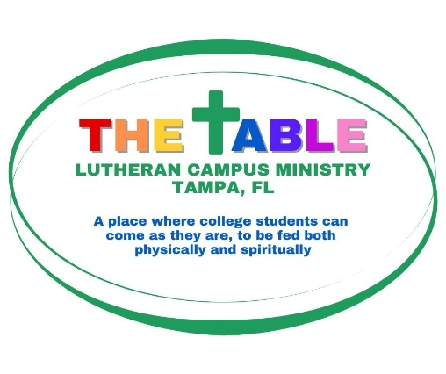
Following many years of networking with Churchwide Campus ministry representatives and Campus Pastors, and the calling of Deacon Tara as Director of Faith Formation at COR, I sensed the time was right to begin again an ELCA presence in the USF/Tampa area.

Bull Market at USF
A Wednesday morning common area of vendors, campus activity, and ministry tables are provided by the University. Both hurricanes delayed some participation. When we are there, information and invitations to The Table are extended, and connections are made bearing witness to the Good News of Jesus from the ELCA perspective. We give away bottles of water, and other small “freebies” are offered for students.

Fall Worship & Activities
In early planning, students were interested in a Dinner Church worship model. This ultimately led us to name the ministry The Table. Currently, we offer Dinner Church once a month, typically the fourth Sunday evening of the month during the school year. The students respond well to this informal, intimate, and conversational time together. Takeout containers are provided for students to take extra homecooked food with them.

The students participated in God’s Work, Our Hands Day in September and assembled baby gift bags for Lutheran Services Florida during their December Dinner Church Gathering.

Special thanks go to Carli Jermier for being a strong supporter and volunteer for this ministry, and to all who have helped with the Dinner Church meals.

Florida-Bahamas Synod & Tampa Conference Dean
Synod Assembly in Orlando with Bob & Jeanne Singagliese, voting members, May 31-June 2
This was my fourth full year as Tampa Conference Dean offering support and care to our Pastors, be on the front line of disaster response, and assisting Tampa area call committees and councils going through a call process through the Office of the Bishop.

Ministry of Support and Administration
Attend meetings and submit report to Council monthly
Assist with Staff Support to offer annual reviews and conversations
Work individually with staff and conduct total staff meetings as needed.
Participate and offer input to all Teams, Committees, and groups
Assist Parish Administrator in congregational record keeping
Assist music staff in worship planning.

2024 Year in Review
In a year of celebrating 40 years of faithful ministry, it was also a year of risk taking in starting new ventures with young adults and senior communities. Even in new beginnings, in risk taking and uncertainties so many of you answered the call to share your gifts and support.
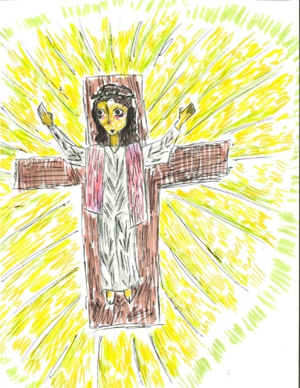
Thank you for your encouragement, generosity, prayer, and responding to be the Kingdom God at Christ Our Redeemer and beyond. Our Lord has been constant in faithfulness, grace, forgiveness, our companion and our goal.

To God be the Glory.
Pastor Eric+

Image of Christ over COR Altar as drawn by Norma Mund, COR youth and confirmand on Ash Wednesday 2024

Christ Our Redeemer in Pictures for 2024

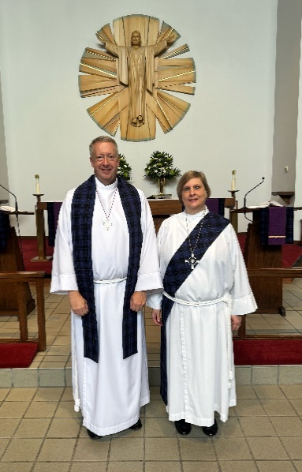
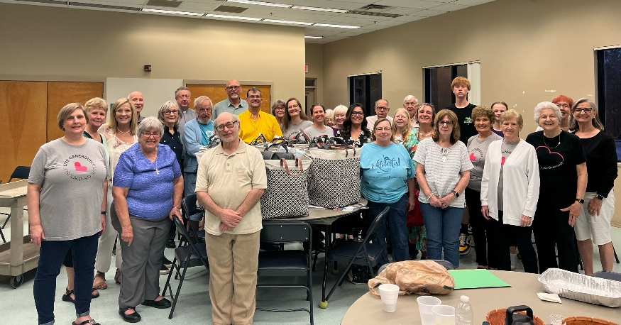
Assembling baby gift bags for LSF, Lenten Dinner Church

Tartan stoles for Celtic Sunday

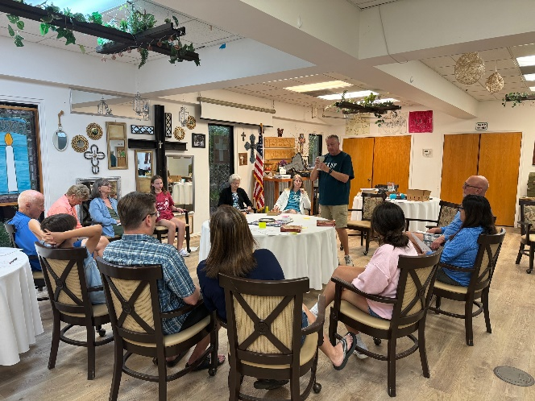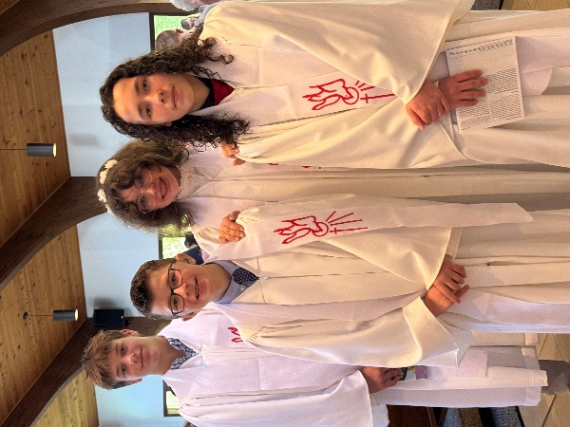
Worship at COR Retreat, Luther Springs 2024 Confirmands

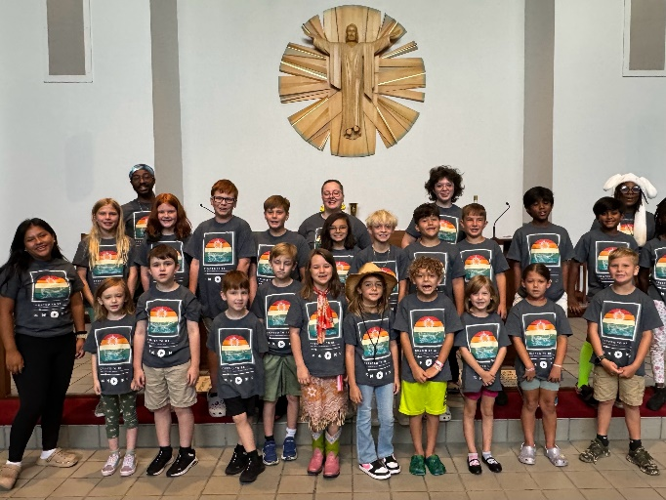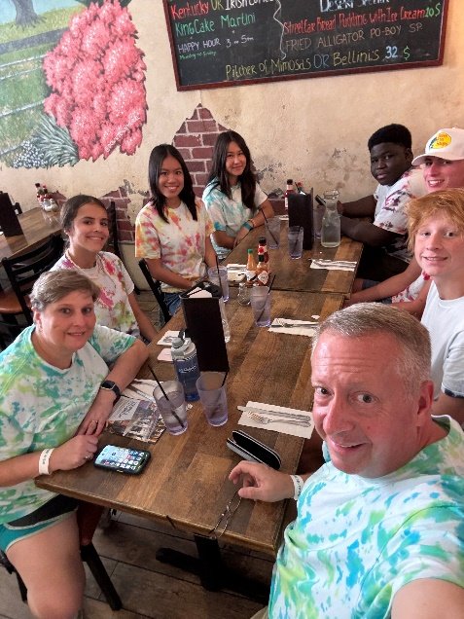
Luther Springs Day Camp at COR ELCA Youth Gathering New Orleans

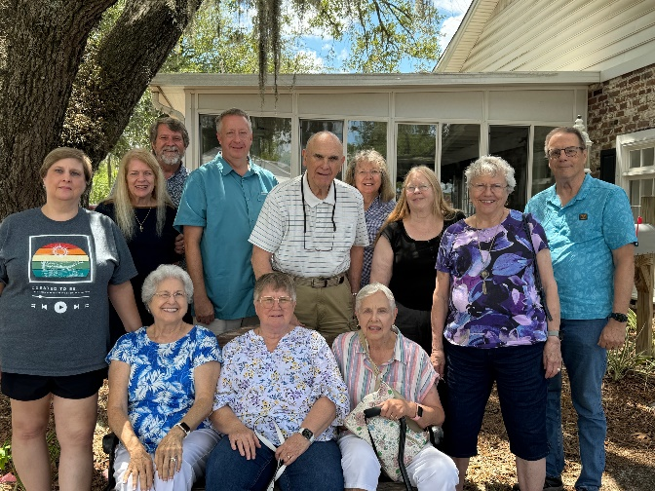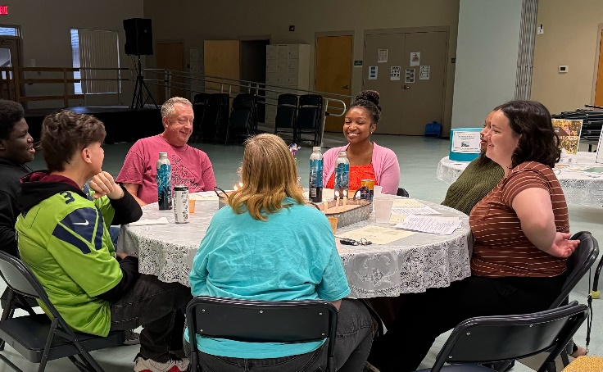
ALOA Retreat in SC Lowcountry, The Table Dinner Church
2024 Director of Faith Formation Annual Report
As the Director of Faith Formation, I plan, lead, and support volunteers in leading faith-based activities and educational opportunities. Throughout the year, I provided opportunities for both the members of our congregation and the local community. I also recruited and trained volunteers and assisted with worship and other functions of the church as needed.
Education Team and Children’s Ministry
I led the Education Team in goal setting, curriculum review, and selecting a new Sunday School curriculum for the children. I recruited new teachers and provided teacher training. I also scheduled teachers, printed curriculum, ordered curriculum resources, set up the Sunday School classroom, organized supplies, and chose age-appropriate Bibles to present to the children for use at home.
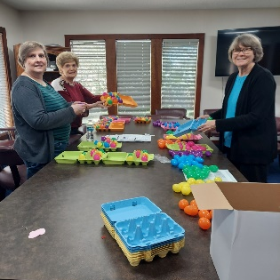
I worked with the Education Team with various projects and events throughout the year. I purchased items and helped assemble Lenten Activity kits and goodie bags for Easter & Christmas Eve. I also helped lead the First Communion celebration, Easter Egg Hunt, Confirmation celebration, Sundae Sunday, Day Camp, Adult VBS, Rally Day, Christmas Traditions Intergenerational Event, Christmas Program, and the Congregational Christmas Party.
Preparing Lenten Kits
Luther Springs Day Camp
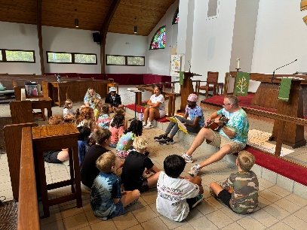
Luther Springs Day Camp was a great addition this year. I created the publicity and oversaw the day camp, June 24-28. We had 22 children from COR and the local community. Luther springs provided a Program Coordinator and three counselors to lead the program. Volunteers from COR helped with registration, snacks, preparing crafts, setting up, and cleanup.

Worship Time

Children & Youth Christmas Program
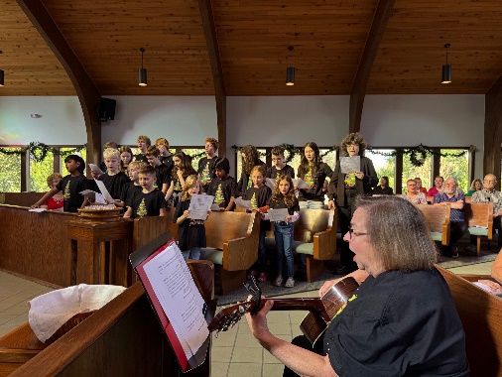
With the help of the Education Team, I organized and directed a Christmas Program during worship on December 15. Twenty-one children and youth participate in the Christmas program, “Building Christmas.” Jan VanBibber worked with the children and youth to teach them two songs for the program. We had a Congregational Christmas party during Sunday School with Christmas brunch, crafts, and Christmas Bingo.

Infant Holy, Infant Lowly
Youth Ministry

I led the High School youth in Bible Studies, preparing for the ELCA Youth Gathering in New Orleans, and four fellowship activities with the high school youth from Atonement Lutheran Church. In July, Pastor Eric and I took Emma Weiland, Anthony Sawaneh, Enrique Fernandez, Erin Browne, and Noah Brockman to New Orleans for the ELCA Youth Gathering.
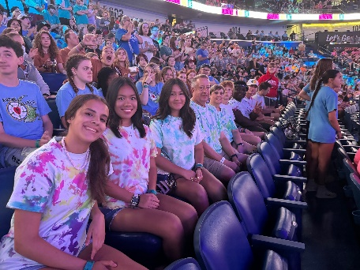
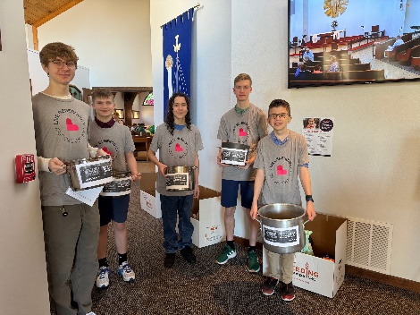

ELCA Youth Gathering Souper Bowl of Caring Collection
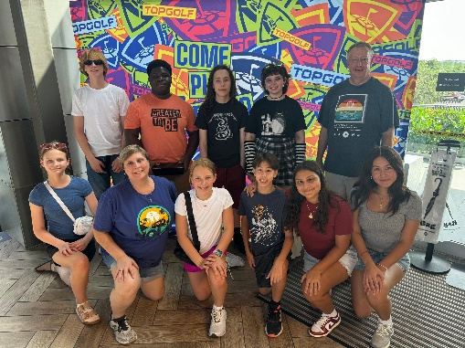

Top Golf

The middle and high school youth met together for most activities, service projects, and fundraisers. The youth participated in Bowling, a Mall Scavenger Hunt with Atonement, TopGolf, and a Late Nite event at church. They also presented a skit for Camp Sunday worship; participated in the Souper Bowl of Caring and collected 466 pounds of food and $900 for Feeding Tampa Bay; hid eggs for the Easter Egg Hunt; helped decorate, set up, serve, and clean up for the Easter Brunch; and painted pumpkins to be raffled off in the Painted Pumpkin Fundraiser.

Outdoor Ministry: Retreats
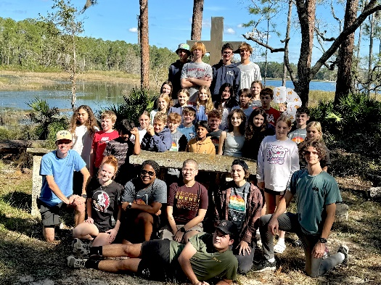
Outdoor Ministry, camps and retreats, is a great way to get children and youth involved and excited about God. Camps and retreats allow us to appreciate God’s great creation, learn new skills, make friends, sing camp songs, and experience worship in different ways. I took 5 youth to Luther Springs in January and 9 youth in November for the Confirmation and Equip Leadership Retreats. The youth also got to go zip-lining at Rock the Canyon at the fall retreat.

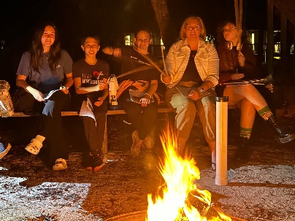
Fall Confirmation/Adventure Retreat
Our Congregational/Family Retreat was at Luther Springs, April 26-28. There were 18 participants, both youth and adults. Pastor Eric, Pastor Meyer, and I provided leadership for this retreat. Participants had a good time growing closer together through group discussions, skits, prayer stations, worship, games, kayaking, archery, a campfire, fellowship time, and meals.
Congregational Retreat
Campus Ministry

In the fall, Pastor Eric and I started The Table: Lutheran Campus Ministry. We met with several college students over the summer to help us plan events for Fall Semester. We decided to start with Dinner Church once a month and several other events for the fall. Pastor Eric and I set up a booth at the Bull Market three times during the semester to promote our campus ministry at USF. I created various publicity flyers and posts for this new ministry and reached out to pastors and youth workers in the Florida Bahamas synod and posted on Facebook groups.
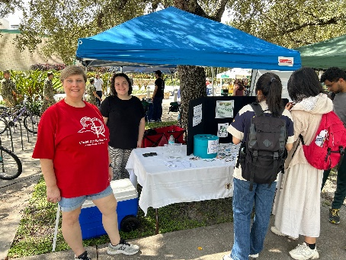
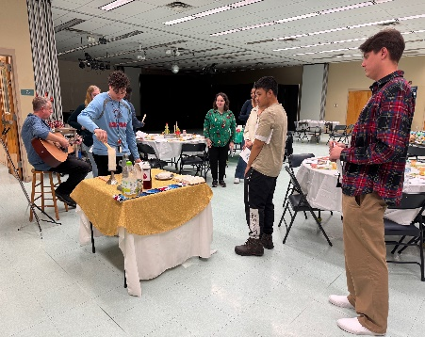

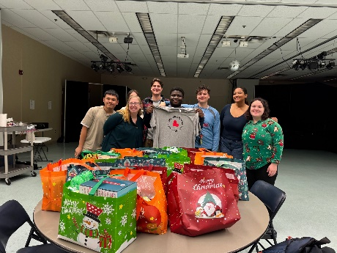
Bull Market Booth Dinner Church

Infant Christmas Bags for LSF

We had four Dinner Churches where the students came together for a free homecooked meal, fellowship, and an interactive worship experience. The students also participated in “God’s Work Our Hands” at Hillsborough State Park doing an invasive plant species cleanup, helped with games at COR’s Oktoberfest, gathered for games and pizza, assembled 16 infant Christmas Bags for LSF, and joined in at Beer & Hymns. We have a core group of around 8 students and a total of around 12 who have participated at least once.
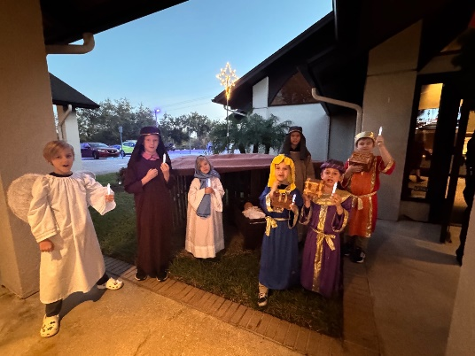
Worship
Worship is a vital part of Faith Formation. It is important that children and youth feel that they are a part of the larger community and that their gifts are being used. I worked with the children and youth to present a skit on Camp Sunday, the Christmas Program, and the Nativity Tableau. I presented Children’s Sermons at worship on Sunday mornings. The Children’s sermon helps children connect their life with one of the daily readings. I also added an activities table in the narthex with quiet toys and activities for children to use during worship. Nativity Tableau

Other ways I served in worship include worship assistant, communion assistant, and playing my flute during worship on special occasions. I assisted with Dinner Church for our Campus Ministry group, helped lead the Lenten Dinner Church on Wednesdays during Lent, led Game Night for Tuesday Tidings in Advent, and helped with the Pet Blessing.

Continuing Education
For Continuing Education, I attended the ELCA Youth Ministry Extravaganza in New Orleans, January 18-21. This was a good opportunity for me to learn more about the upcoming Youth Gathering and keep up with current Youth Ministry and Education skills and trends. I also attended the Florida-Bahamas Conference on Ministry: Rostered Leaders Retreat in September.

Administration
Communication is very important for my ministry. I provided information for the bulletin and email blasts, created newsletters, updated the bulletin boards, and sent emails to parents, youth, and teachers as needed. I attended monthly Council meetings, Education Team meetings, VBS Planning meetings, Tampa Bay Area Youth Workers meetings, Tampa Conference meetings, and Synod Assembly.

A big “thank you” to the Education Team and Faith Formation teachers, chair: Tilly Anderson, members: Sue Hutting (elementary), Geneva Meyer (preschool/elementary), Clarann Smith (preschool/elementary) Jen Broecker (elementary), Melissa Williams (elementary), Eileen McGrath (elementary), Gracie Bade (elementary), Gayle Miller (Confirmation), Beth McCullough (First Communion 2024), Sr. Anne Hall (First Communion 2025); Pr. Wally Meyer, Pr. Dave Hall, and Pr. Marilynn Crosby (Sunday Adult Bible Class); Sue Huttig & Bev Bauder (Tuesday Bible Study); and Bekki Reid (Saturday Bible Study).
Thank you to all the volunteers for Day Camp: Bekki Reid (Registration Coordinator), Sherry Black (Craft Coordinator), Geneva Meyer (Snacks Coordinator), Jan VanBibber and Diana Lyles (Nurses); Carli Jermier, Bekki Reid, & Vickie Sufka, (Check-in & Check-out); Eileen McGrath, Melissa Williams, Sharron Oaks, Sara McMurry, Annie Piazza (Snacks and Lunch Helpers); Norma Mund (Youth Assistant); Todd & Tilly Anderson and Keith & Gayle Miller (Counselor Hosts); and Pastor Eric (Guitar).

Thank you to the Campus Ministry volunteers: Carli Jermier (Program Assistant); Linda Tolly (Dinner Church Meals Coordinator); Gayle Miller, Bev Bauder, Vickie Sufka, Carli Jermier, Tilly Anderson, Katy Saunders, and Sr. Anne Hall (Meals Helpers).

Thank you to all the parents, grandparents and other volunteers who assisted with activities and provided meals and snacks. Thank you, to our wonderful congregation who support our children youth, and campus ministry in their many activities.

In Christ,
Deacon Tara Friedrichs
Director of Faith Formation

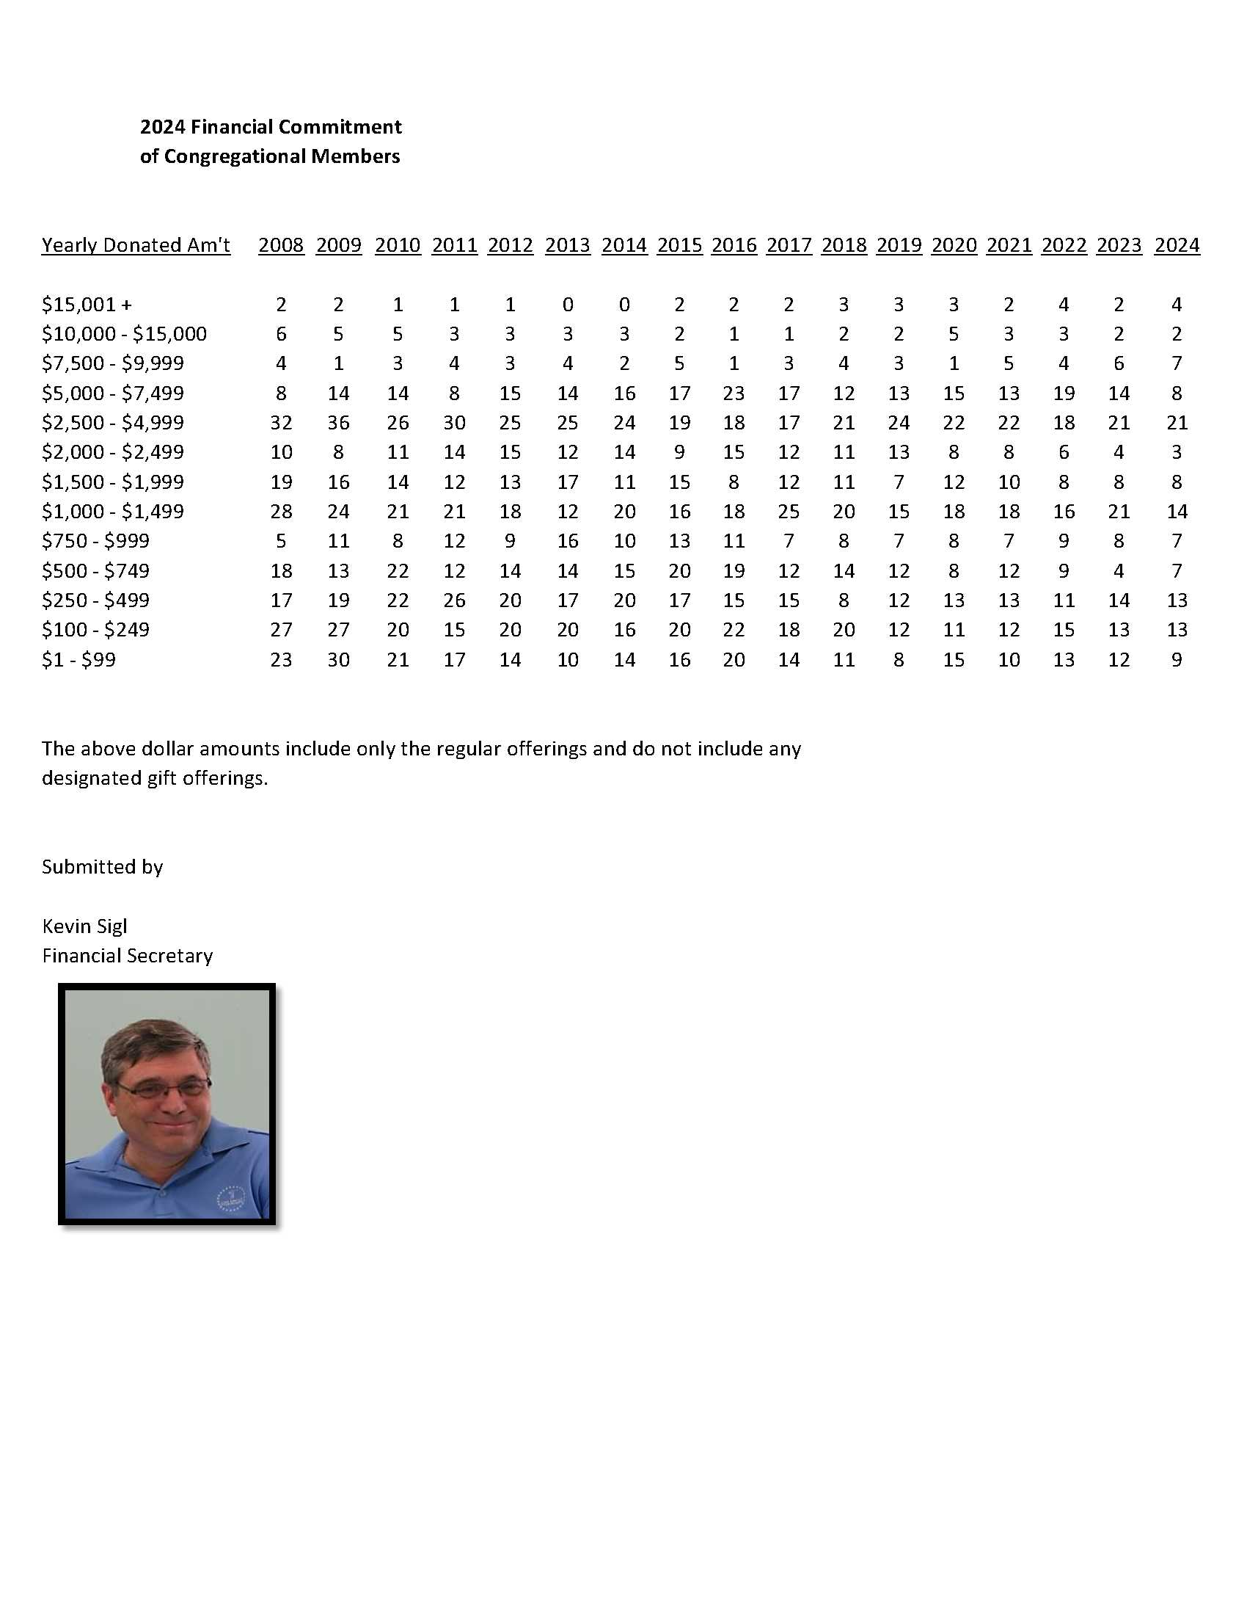

Education Team 2024 Annual Report
The Education Team of Christ Our Redeemer is dedicated to fostering spiritual growth and education among our congregation. This annual report summarizes our activities, achievements, challenges, and future goals for the year 2025.

Program Overview

Sunday School
- Overview: A program for children Pre-K through 5th grades that focuses on teaching the foundational stories of the Bible.
- Curriculum theme was Building Our Foundation with Jesus and the theme verse was God is the builder of everything. Hebrews 3:4
- Key Activities: Weekly classes, seasonal events, and family activities, such as First Communion celebration, Easter Egg Hunt, Confirmation celebration, Sundae Sunday, Day Camp, Rally Day, Christmas Traditions Intergenerational Event, Christmas Program, and the Congregational Christmas Party

Adult Bible Studies
- Overview: Various classes designed for adults to deepen their understanding of Scripture.

Youth Ministry
- Overview: Engaging programs for youth aged 6th-12th Grade, focusing on fellowship and service.
- Activities: Retreats, service projects, and social events including ELCA Youth Gathering in New Orleans, and fellowship activities with the youth from Atonement Lutheran, Bowling, a Mall Scavenger Hunt with Atonement, and a Late Nite event at church
First Communion Classes
- Overview: Classes designed to give guidance on how to approach the altar, what to say when receiving Communion, and any specific practices or traditions of the local congregation.
- Number of students: 4, Thomas Barton, Dean Broecker, Jaxen Giobetti, & Dylan Homuth

Confirmation Classes
- Overview: Classes designed for youth preparing for confirmation, focusing on Lutheran teachings and practices.
- Number of Confirmands: 4, Alex Fawcett, Logan Mayora, Norma Mund, & William Musser

Vacation Bible School (VBS)
- Overview: A week-long summer program for children featuring Bible stories, crafts, and games.
- Attendance: 22 children participated in 2024

Highlights of the Year
- Successfully launched a new curriculum for Sunday School that emphasized Building a foundation with Jesus,
- Increased attendance in adult Bible studies compared to the previous year.
- Youth group organized a community service project that provided Baking cookies and making cards for senior adults
- Held a successful VBS engaging both COR and local community children.
Challenges and Areas for Improvement
- Some programs experienced lower attendance than anticipated; strategies for increasing participation will be explored.
- Need for more volunteer involvement in youth and young adult programs to enhance mentorship opportunities.
Future Plans
- Expand the curriculum for Sunday School to include more intergenerational activities.
- Plan a church-wide retreat to strengthen community ties and spiritual growth.
We extend our heartfelt thanks to all volunteers, teachers, and participants who contributed their time and talents to our educational programs. Special thanks to Deacon Tara (Director of Faith Formation), Sue Hutting (elementary), Geneva Meyer (preschool/elementary), Clarann Smith (preschool/elementary) Jen Broecker (elementary), Melissa Williams (elementary), Eileen McGrath (elementary), Gracie Bade (elementary), Gayle Miller (Confirmation), Beth McCullough (First Communion 2024), Sr. Anne Hall (First Communion 2025) all the parents, grandparents and other volunteers who assisted with activities and provided meals and snacks. Thank you again for your exceptional service this year.
Looking ahead, we are excited about the opportunities that await us in the coming year. With God’s guidance, we will continue to strive for excellence in education, fostering an environment where faith and learning flourish together.

May we all remain united in purpose and spirit as we embark on another year of growth and service.

In Christ’s love,

Tilly Anderson
Education Chair
COR Education Team
FELLOWSHIP TEAM 2024 REPORT
The Fellowship Teams is responsible for hosting events throughout the year to bring the church together in socialization and to reinforce a sense of community.

The Fellowship team started off the year with Lent Season and delicious potlock dinners for Wednesday worship.
Cinco de Mayo event was held after Sunday church service on 5/5. Event was well received with a great attendence turnout although a bit warm. There were bounce houses, water balloons, pinata’s, music and great food.
Fourth of July parade was well received. The team and volunteers handed out water, ice pops and corn dogs for parade participants.
Octoberfest was a great event again this year. The Fellowship team assisted the event wherever was needed; set up, take down, overseeing games. This helped make a great day for all.
Ended the year with Advent dinners. Week 1 was caroling at Concordia followed by a light dinner in the fellowship hall with soup, salad and sandwiches. Week 2 was trivia with a “Taco Tuesday” theme. Week 3 was Beers & Hymns at Shamrocks. All who attended enjoyed great food and fellowship celebrating the birth of our Lord.
We would like to thank Pastor Eric, Vickie and all the Council members for their support.
Fellowship Team Members – Candice Fraga, Sharon Fraga, Joy Austin, Nicole Heidt, Bea Shirling and Tim Bahr

Respectfully submitted,
Candice Fraga / Sharon Fraga

Member Care 2024 Annual Report

In January of 2024, we were blessed to welcome 15 new members including children. Our New Member luncheon was well attended.
We held 5 receptions in the Fellowship Hall for the 6 members who died this past year. One reception was held at Miller’s Ale House on Fowler Ave.
Flowers are delivered to all shut-ins and those sick or hospitalized on a rotating basis. Jean Archer, Sharron Oakes and Denise Lyles use Sunday’s altar flowers to arrange bouquets which I or Elizabeth Chester deliver.
Several members coordinated and produced the play, “The Last Supper” which was held on Maundy Thursday.
CPR classes were given to 20 congregation members in August by a registered nurse from Faith Community Nursing at St. Joseph’s Hospital, Tampa.
We had a speaker about “Personal Safety” at a Pot-Luck in September.
The RN’s at church helped with the Day Camp at COR and also took B/Ps at Octoberfest.
In November, Denise Cook, Esq. gave a lecture on “Avoiding Scams” at one of our Potlucks. We will have more in 2025 on a variety of subjects.
Member Care Team: Diana Lyles, chairperson, Sharron Oakes, Melissa Williams, Bev Bauder, Rita Cassidy, Gene Dressler, Sara McMurry, Sister Anne Hall, Eileen McGrath, Kathy Daily, Dave and Denise Cook, Charles Rodriquez.

In His Service,
Diana Lyles, Member Care Chair

Outreach Team Report for 2024

We continued our mission to get back into the community and connect with people. We hope to continue this in the upcoming year.
Thanks to Julia Scott we have a wonderful team of Greeters welcoming all of our members and visitors throughout the year.
Outreach Team Members: Christina Mayorga, Bekki Reid, Betty Chester, Catherine Mund, Erik Mayorga, Norma Mund and Logan Mayorga

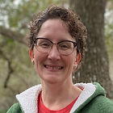
Respectfully Submitted,
Christina Mayorga
Outreach Chair

Property Report for 2024
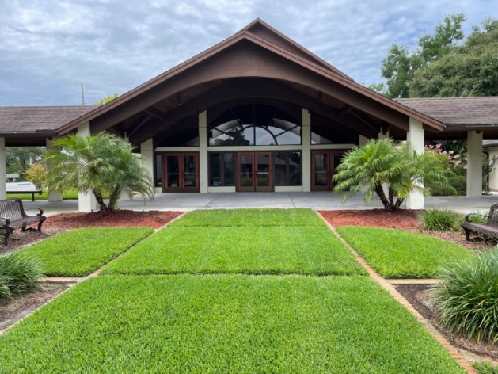

The past year we have completed multiple projects at COR.
Here are a few:

• Replaced 2 roofs on the lower classrooms from hurricane damage
- Remodel of several classrooms and Focus Academy offices to improve their facilities
- Painted exterior of the Sanctuary, Fellowship Hall and Administration Building
- Contracted a maintenance agreement for the Air conditioning units for the entire campus

Here are a few ideas we are working on for 2025

• Replacement of all the exterior doors on the Sanctuary
• New upholstery and refinishing the wood on the pews and choir chairs
- Remodel the bathrooms in the Administration Building
- New landscaping in the Memorial Garden and around the Sanctuary

I would like to thank the congregation and the memorial committee for all the funding provided for all the projects this past year and year to come.
If you would like to help with planning and implementing new projects, please join me and Mike Scott on the Property Committee.

Respectfully,
Ken Oleson, Property Chair

Social Ministry Team 2024
The Social Ministry team at COR in 2024 has had an active year. We continued to volunteer in food pantries, collected items for those in need and have shared monetary offerings with those less fortunate, specifically in 2024 we have:
- Supported Temple Terrace Elementary School food pantry by having a cereal drive.

- Collected and shipped over the counter medications to Teneba's Haven in Sierra Leone, Africa

- Worked with a recently confirmed member of our congregation to help her reach her goals for a Girl Scout project by sponsoring a drive to collect toiletries and comfort items that were donated to a foster care program in west Tampa.

- Collected funds and laundry products and donated them to 2 laundromats in Temple Terrace. (As a project for God's Work, Our Hands)

- Participated in Lutheran Services of Florida's Christmas Angel project, collecting Christmas toys for children in their foster care program.
With our monetary offerings received throughout the year, the Social Ministry has also been able to send monetary support to the following organizations:
- Teneba's Haven
- Lutheran Services of Florida
- Lutheran Disaster Response
- Village of Hope
- Novus Way Ministries
- Metropolitan Ministries
- ELCA World Hunger/Good Gifts
We look forward to 2025 to continue to share the love of Christ with our church and community.

Respectfully submitted,
Jan VanBibber
Chair of Social Ministries
Worship Team 2024

The worship Committee is responsible for all worship services of the congregation and the personnel and materials necessary for their conduct; and developing staff of ushers, acolytes, liturgical assistants, lectors, Altar Guild, musical assistants, music groups, sound system operators and nursery personnel. The organist and music director are advisory members of this committee.

We have had a busy worship year this year. We continue our 9:30 am Sunday worship which is livestreamed and recorded on Facebook and YouTube. This is a great tool for shut-ins, people travelling or home sick. It is also nice to be able to watch it again after Sunday service.

Our music program adds so much to our worship. Between choir, handbells, Americana, Jazz, and all the other musicians we are blessed that our services are never without music. We also added a Celtic themed service which everyone enjoyed. Thanks to Chris Robinson, Elizabeth Chester, and Pastor Meyer for coordinating all the different groups and types of worship settings!

Our mid-week services for Lent and Advent continued with different themes and organizations that receive the offering. We also had great services for Palm Sunday, Easter, Reformation, All Saints Day and of course Christmas Eve. Advent “Tuesday Tidings” moved our mid-week services from Tuesday to Wednesday. These changes were well received and kept the choir on their normal schedule, so they didn’t get home late on Wednesdays.

I would like to thank Geneva Meyer for coordinating the Nursery attendants. She makes sure someone is there for our little ones every Sunday.

Shirley Landberg retired from Altar Guild this year. We thank her for her dedication and service setting up and taking down the communion and altar linens every week. Thanks Shirley!

I would also like to thank Pastor Eric for his leadership and wisdom this year.

Worship Team Members: Jeanne Singagliese, Clarann Smith, Sue Oleson, Katy Saunders
Advisory Members: Elizabeth Chester and Chris Robinson

Respectfully submitted,

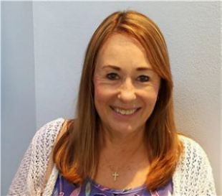
Jeanne Singagliese
Worship Team Chair

